The Patriarchs from the book of Genesis Part 23 – February 25, 2024
With input from https://www.bibleref.com/Genesis28; https://bible-history.com/map-israel-joshua/the-hivites-1#google_vignettel; https://www.thecollector.com/who-were-the-hittites/

Last week we noted that because of Esau’s action of putting himself first and not putting God first in life, he is called godless in Hebrews. His offspring, the Edomites are cursed when God comments: Malachi Chapter 1:3 (repeated in Romans 9) But Esau I have hated, And laid waste his mountains and his heritage, Jacob have I loved but Esau have I hated.

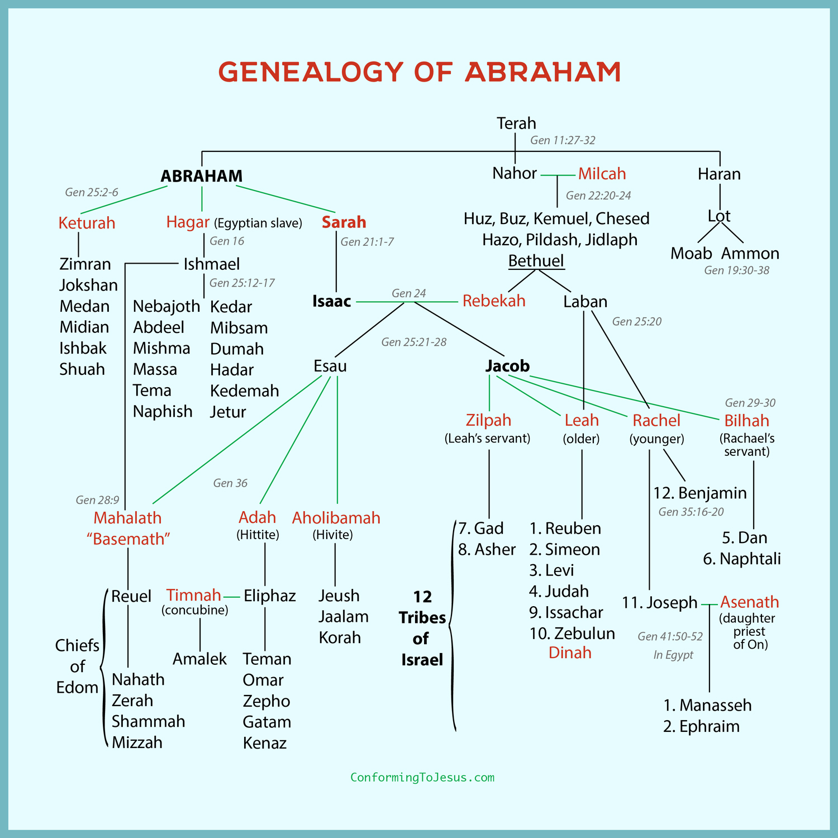

Genesis 27:41 So Esau held a grudge against Jacob because of the blessing with which his father had blessed him; and Esau said to himself, “The days of mourning for my father are near; then I will kill my brother Jacob.” 42 Now when the words of her elder son Esau were reported to Rebekah, she sent word and called her younger son Jacob, and said to him, “Behold your brother Esau is consoling himself concerning you by planning to kill you.

43 Now then, my son, obey my voice, and arise, flee to Haran, to my brother Laban! 44 Stay with him a few days, until your brother’s fury subsides, 45 until your brother’s anger against you subsides and he forgets what you did to him. Then I will send word and get you from there. Why should I lose you both in one day?”

46 And Rebekah said to Isaac, “I am tired of living because of the daughters of Heth; if Jacob takes a wife from the daughters of Heth like these from the daughters of the land, what good will my life be to me?”

Rebekah does not tell Isaac her true fear that Esau would kill Jacob. Perhaps she doesn't think that would compel Isaac to act quickly enough. Perhaps she doesn't think Isaac would believe such a thing of his favorite son. Instead, Rebekah manipulates Isaac once again, this time by complaining about Esau's wives, the Hittite women who had made life bitter for both of them, according to Genesis 26:35. Now she says to Isaac colorfully that she hates her life because of those women. In fact, what good will her life even be if Jacob also marries one of the local women?

She does not come out and say directly that Isaac should send Jacob to her brother to find a wife. At least, we're not told that she does so. Still, in the following verses Isaac will send Jacob away for that very reason. Rebekah has accomplished her goal to get Jacob out of town. This, so far as Scripture is concerned, is the last time Rebekah will see Jacob (Genesis 27:43–44). His reunion with Isaac will happen many years later (Genesis 35:27), but no mention is made of his mother, who presumably has passed away, never again seeing her favorite son (Genesis 49:31).

Genesis 29 starts with Isaac acting on Rebekah's suggestion, probably still unaware of Esau's plan to kill Jacob. Instead, he has agreed with his wife and also with his own father. Abraham had insisted that Isaac not marry a local Canaanite woman (Genesis 24:3). He did not want Isaac to assimilate into the local population. Now Isaac places a similar requirement on Jacob. It was too late for Esau to not marry locally, but Jacob could still marry from among the women of his mother's people.

Remember that the Canaanite people are cursed by Noah as the son of Ham. They become so evil that they are known to sacrifice children to their gods.

Genesis 28: 1-9 So Isaac called Jacob and blessed him and commanded him, saying to him, “You shall not take a wife from the daughters of Canaan. 2 Arise, go to Paddan-aram, to the house of Bethuel your mother’s father; and from there take to yourself a wife from the daughters of Laban, your mother’s brother.

Abraham, old and possibly near death himself, had once sent his servant to find a wife for Isaac in Mesopotamia (Genesis 24:2–4). Isaac, also old and near death, is sending Jacob to find a wife for himself. However, Isaac's command is much more specific: Jacob is to marry a daughter of Laban, Rebekah's brother. Though Jacob will do exactly this—twice, in fact—it doesn't seem to leave much room for him to maneuver. Perhaps Isaac knew of Rachel and Leah already and thought one of them would be a good wife for Jacob.
3 May God Almighty bless you and make you fruitful and multiply you, so that you may become a multitude of peoples.

Isaac now gives to Jacob an even more complete blessing than he had before when he thought he was blessing Esau (Genesis 27:27–29). This is the full blessing of the covenant between God and Abraham's descendants. Perhaps even Isaac thought the full covenant blessing was inappropriate for Esau, given his disposition and intermarriage with Canaanite women (Genesis 25:29–34; 26:34–35).

In any case, Isaac begins here by asking God Almighty to bless Jacob by multiplying him with descendants. He prays for Jacob to become a company—or "multitude"—of peoples.

4 May He also give you the blessing of Abraham, to you and to your descendants with you, so that you may possess the land where you live as a stranger, which God gave to Abraham.” 5 Then Isaac sent Jacob away, and he went to Paddan-aram to Laban, son of Bethuel the Aramean, the brother of Rebekah, the mother of Jacob and Esau.

6 Now Esau saw that Isaac had blessed Jacob and sent him away to Paddan-aram to take to himself a wife from there, and that when he blessed him he commanded him, saying, “You shall not take a wife from the daughters of Canaan,” 7 and that Jacob had obeyed his father and his mother and had gone to Paddan-aram. 8 So Esau saw that the daughters of Canaan displeased his father Isaac; 9 and Esau went to Ishmael, and married, besides the wives that he had, Mahalath the daughter of Ishmael, Abraham’s son, the sister of Nebaioth.

Remember that Esau and the Edomites, and all of Esau’s offspring are cursed. Notice back in our chart that the Hittites are one of the lines of Esau through his wife Adah. The Hittites were an ancient Anatolian (modern-day Turkey) people who formed an empire between 1600-1180 BCE. The Hittites manufactured advanced iron goods, ruled over their kingdom through government officials with independent authority over various branches of government, and worshipped storm gods.

It is believed that the Hittite capital of Hattusa was sacked by the Kaskas in 1190 BC and burnt to the ground, gradually becoming abandoned over a period of several decades as the Hittite Empire disintegrated to the encroaching Assyrians.

Then the Hivites come from the third wife of Esau (cursed) and they were of the line of Canaan (cursed). The Israelites conquered the Hivites but later the Hivites made friends with the Israelites. In Joshua 9, Joshua enslaved the Hivites of Gibeon to be wood gatherers and water carriers for the Temple. The Bible records that David's census included Hivite cities. Solomon chose them to be servants in his Temple in Jerusalem in 1 Kings 9:20-21. The names of any Hivites are scarce and therefore it is difficult to know the language they spoke, but was no doubt similar to the other Canaanite tribes in the land and close to ancient Hebrew.

In Genesis 28:10 we return to Jacob’s story, but it is good to remember here that Jacob, for his part, will experience a taste of his own deception when he attempts to obtain a wife from his relatives in this new country.

Genesis 28:10 Then Jacob departed from Beersheba and went toward Haran. 11 And he happened upon a particular place and spent the night there, because the sun had set; and he took one of the stones of the place and made it a support for his head, and lay down in that place.

This verse raises several questions. Was Jacob not well prepared for this journey? Did he leave in a great hurry? Or was he far from any place where he could more safely spend the night than alone on the ground with a stone for his pillow? It seems somewhat odd that the son of a man as wealthy as Isaac is apparently traveling with no servants or larger company. At least, Scripture gives us no indication of others travelling with him.

Whether through haste, poor planning, or some other circumstance, this passage presents Jacob as a man alone in the desert, vulnerable to what may come. When it gets dark, he is forced to stop for the night. He grabs a stone, lays his head on it, and goes to sleep. He did not yet know that the place he slept would become such a significant place in the story of God's relationship with Israel.

12 And he had a dream, and behold, a ladder was set up on the earth with its top reaching to heaven; and behold, the angels of God were ascending and descending on it.

As the dream begins, Jacob sees a structure connecting earth to heaven. The Hebrew word for this object is sul'lam, which appears only here in the Bible. The term is often translated as "ladder," but it could possibly be interpreted as a "staircase." Either way, this construction is occupied by God's angels ascending and descending. The text states this with a sense of astonishment, perhaps expressing the feelings of Jacob in the dream. Because of it’s grandeur, I believe it to be more like a staircase.

13 Then behold, the Lord was standing above it and said, “I am the Lord, the God of your father Abraham and the God of Isaac; the land on which you lie I will give to you and to your descendants.

To begin with, the Lord will give to Jacob and his descendants the very ground on which he is lying. In this way, the Lord acknowledges Jacob's experience while lying there asleep was both a dream and a genuine visitation from God.

14 Your descendants will also be like the dust of the earth, and you will spread out to the west and to the east, and to the north and to the south; and in you and in your descendants shall all the families of the earth be blessed.

One has to wonder if Jacob has heard these words before. Had Abraham or Isaac ever quoted to Jacob these promises from God? We don't know, though Isaac had said somewhat similar things to him in delivering the blessing of Abraham before sending Jacob off on this journey. In any case, the Lord does say to Jacob nearly the exact words He said to Abraham. Jacob's offspring will become as the dust of the earth (Genesis 13:16). They will spread in every direction across the land. However, they will not only conquer and occupy. Through Jacob's descendants, all the people of the earth would be blessed (Genesis 12:3).

Many interpreters see this promise—to bless all the people of the earth through the descendants of Abraham and Jacob—as the Lord pointing forward to Jesus Christ. Jesus, the Savor and Messiah, will make it possible for people of every family and nation to become the people of God. Jesus will be one of the direct descendants of Abraham, Jacob, and their offspring.

15 Behold, I am with you and will keep you wherever you go, and will bring you back to this land; for I will not leave you until I have done what I have promised you.” 16 Then Jacob awoke from his sleep and said, “The Lord is certainly in this place, and I did not know it!” 17 And he was afraid and said, “How awesome is this place! This is none other than the house of God, and this is the gate of heaven!”
When we look at Jacob and see his deception and evil, we wonder why God still plans to bless him and even pronounce a great blessing on him in this passage. This is important in our own lives as we wrestle with God’s election of some people to salvation and others to eternal damnation.

John MacArthur: I think a large majority of where people stumble, is over the total depravity of mankind. If you don't start with the total depravity of mankind, and understand that we are dead in our sins and trespasses, you'll never get unconditional election as the Bible teaches it. And it's one of the reasons, some of the imagery that's used of salvation is, one, that we're born again; and two, that we've been resurrected. And how many dead people caused their own resurrection? And how many babies, before they were conceived, did something to lead to their birth?

The answer is absolutely nothing. And I think that's why those analogies or pictures of life are used, because it points to all of humanity; dead in their sins and trespasses, personally culpable before God for their sins, deserving of nothing, and if God had only exercised His justice and His righteousness, only God the Father, God the Son, God the Holy Spirit and the angels that didn't fall would be in heaven. God could have done that if He wanted to.

The second one is we have a very hard time as human beings believing that we can't think on the same level as God. And that's deifying the human mind and humanizing the divine mind. And if we think we can understand everything that's in the mind of God, which we can't, we will then conclude that it's unfair, not right, for God to do what He does, because that makes Him a cosmic puppeteer, and all we are is people who go through life and everything we do and say and everything—we have nothing to be involved in.

So we need to park our pride on our humanity—the ability to think and see ourselves as sinners, lost forever apart from God's unmerited favor and His grace, unconditionally bestowed by election—and see ourselves as Isaiah saw the mind of God in Isaiah 55 that just clearly says God's thoughts are so far above our thoughts that it's the difference between the distance from heaven, which we can't measure on earth..

Deuteronomy 7:6 and 14:2 says, “The Lord your God has chosen you to be a people for his own possession out of all the peoples that are on the face of the earth.” And God said it wasn’t because you were better than any other people, it wasn’t because you were more attractive than any other people. God said it is because I of my own free will predetermined to set my love upon you and for no other reason. Israel, mine elect. God calls them.

It never says God created vessels prepared for destruction, that’s double predestination, and the Bible doesn’t teach that. It says he “endured with much patience vessels of wrath - ” passive “ - prepared for destruction.” Not that he prepared for destruction. God doesn’t go down the list of humans to come and say, “Okay, you go to heaven, and you go to hell, and you three go to hell, and you go to heaven, and you ten go to hell, you go to heaven.”

The Bible doesn’t teach that. The Bible teaches that all men are on their way to hell. And God chose to rescue some and he endured the others who are headed that way not because of something God did, not because of a decree that God made individually for them, but because they continue in their sins and are fully guilty. God has every right to demonstrate his wrath, and he is as much glorified in his wrath as he is in his mercy.

