The Patriarchs from the book of Genesis Part 20 – January 28, 2024
With input from https://www.bibleref.com/Genesis25
The Genesis Record by Henry Morris pages 401-420; https://www.conformingtojesus.com
https://hermeneutics.stackexchange.com/questions/17528/is-salem-in-genesis-14-a-shortened-form-of-jerusalem

We concluded with the marriage of Isaac and Rebekah last week:

Genesis 24:67: Then Isaac brought her into his mother Sarah’s tent, and he took Rebekah, and she became his wife, and he loved her; so Isaac was comforted after his mother’s death.

There are a lot of details now in Genesis 25 that affect the children of Israel, their land, and problems that continue to this day. In chapter 25 Abraham’s last 37 years only take up 6 verses before his death in verses 7-8. This week we will outline the chapter and events in order to help us to see them more academically and to remember them for future chapters:

When did all this happen:
- Abram was born in approximately 1996 B.C. (ICR estimates 2166 – 156 yrs earlier) and died in 1821 B.C. at 175 years old (Gen 25:7). Flood year likely 2472 – Abraham 300 yrs later
- Isaac, according to Genesis 25:20, was 40 years old when he married Rebekah (1856 B.C.). Genesis 25:26 tells us Isaac was 60 years old when Esau and Jacob were born (1836 B.C.).

Who: The following biblical characters are all in chapter 25:

Abraham – A man from Ur of the Chaldeans who moved to Canaan at God’s instruction. God promised to make his descendants a great nation and to give them the land of Canaan.
Keturah - Bible interpreters disagree about when Abraham married Keturah, his "other wife." Does the text mention this marriage here because it came after Sarah's death, as has been traditionally understood? This is possible, but ancient literature was not written in the same chronological sense as modern history. The other possibility is that Abraham married Keturah before Sarah died. Given that Abraham had six children with Keturah, it’s possible theirs was an ongoing relationship, not one which did not even start until Abraham was nearly 140 years old (Genesis 23:1–2; 17:17).

The text is not clear as to which of these two options is the truth. In 1 Chronicles 1:32, Keturah is described as Abraham's concubine. In any case, the verses in this chapter will reveal that Abraham had six sons with Keturah. None of them were included in the covenant promises given by God to Abraham and then Isaac.
Ishmael – Abraham’s son with Hagar, Sarah’s Egyptian servant.
Isaac – Abraham’s son with Sarah.
Rebekah – Isaac’s wife, the daughter of Bethuel, nephew of Abraham through
Jacob and Esau – Twin brothers born to Isaac and Rebekah.

Where: Isaac lived in Beer-lahai-roi, we first heard of this city when Hagar left Sarah in Genesis 16:14 Ishmael’s family lived between Havilah and Shur (south of the Negev).
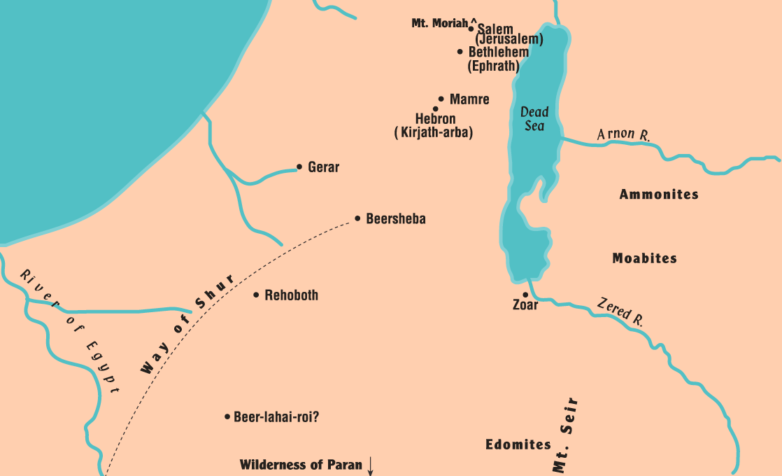
Notice that during the early years in Genesis, with reference to “the king of Salem” in Genesis 14:8, that this is Jerusalem before Jeru was added.

https://hermeneutics.stackexchange.com/questions explains it like this:
‘Jerusalem’ is not a Hebrew word we can properly parse because it’s a transliteration of an older Semitic word. As a city name Jerusalem predates the Hebrew language by at least a millennium; its first known appearance is in Egyptian execration texts in the 20th century BCE. According to Yisrael Shalem, the exact pronunciation of the hieroglyph is uncertain but probably sounded like ‘rushalimum’. The name also appears in the 14th century BCE Amarna letters, and later Akkadian texts refer to the city as Urusilimu. The original Hebrew pronunciation probably sounded like ‘Yerushalem’. Jerusalem is therefore the English transliteration of the Hebrew transliteration of the city's original Canaanite name.

Given its Canaanite origins, Jerusalem likely means ‘the city of Shalem’ or ‘foundation of Shalem’, Shalem being the Canaanite god of dusk (or the evening star) in the Semitic pantheon. Jerusalem is therefore a theophoric name, containing within it the name of its tutelary deity. Shalem may also have lent his name to the city of Salim near Shechem (Gen.33:18, Jn.3:23).

Gen.14:18 calls Melchizedek the king of Shalem (שָׁלֵם, H8004), which most scholars equate with Jerusalem. The only other biblical occurrence of this word is Ps.76:2 where Shalem parallels Zion, making the association with Jerusalem clear.

At some point, though, ‘shalem’ lost its cultural connection to the Canaanite divinity and instead came to connote peace, as reflected in the Hebrew root word שָׁלַם (shalam, H7999). The Christian writer of Hebrews 7:2 can therefore write, “First, the name Melchi-zedek means 'king of righteousness'; then also, 'king of Salem' means 'king of peace'” (NIV). The old Canaanite gods Tzedek and Shalem live on, but now only as the godly virtues of ‘righteousness’ and ‘peace’, respectively, and Jerusalem is the hoped-for City of Peace.

Gensis 25:1-6: Now Abraham took another wife, whose name was Keturah. 2 She bore to him Zimran, Jokshan, Medan, Midian, Ishbak, and Shuah. 3 Jokshan fathered Sheba and Dedan. And the sons of Dedan were Asshurim, Letushim, and Leummim.

4 The sons of Midian were Ephah, Epher, Hanoch, Abida, and Eldaah. All of these were the sons of Keturah. 5 Now Abraham gave all that he had to Isaac;

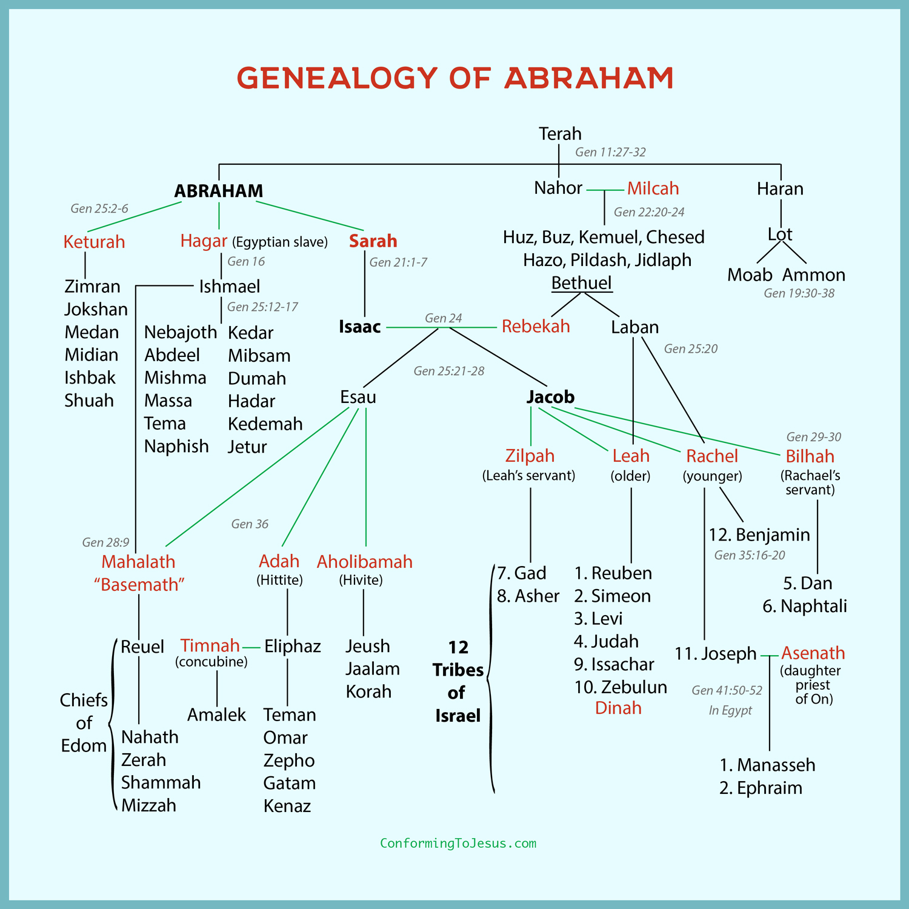

6 but to the sons of his concubines, Abraham gave gifts while he was still living, and sent them away from his son Isaac eastward, to the land of the east.

Old records clearly link the north Arabians with Ishmael’s descendants” (“Ishmael and the Bible,” Emmaus Journal 13:2, 2004). But it’s unlikely that all of those in Arabia are descendants of Ishmael, as the descendants of Keturah and the children of Esau also lived in the Arabian Peninsula.

Verse 5 Makes it clear that Abraham gave the majority of his great wealth to Isaac. In addition, God's covenant promises were established with Isaac. He was the child of the promise. It was Abraham's line through Isaac that would result in God's chosen people Israel and, eventually, lead to Christ Himself.

However, Abraham did not leave his sons by his concubines empty handed. Though never referred to as a "concubine" exactly, it's possible that this includes Hagar (Genesis 16:1–3). Abraham showed great affection for Ishmael, his son by Hagar, and Ishmael will participate in Abraham's burial in the following verses. Keturah, Abraham's "other wife" after Sarah, is referred to as a concubine in 1 Chronicles 1:32. We're not told of any other women who would have been considered Abraham's concubines.

In any case, before Abraham died he gave gifts, probably from his vast wealth, to each of these sons and sent them away from Isaac. Abraham was intent that Isaac remain in the promised land of Canaan and that there be no confusion, even after his death, about exactly who Abraham's sole heir was. To that end, Abraham sent all of these other sons away to the desert regions east of what would later become Israel.

Genesis 25:7-11: These are all the years of Abraham’s life that he lived, 175 years. 8 Abraham breathed his last and died at a good old age, an old man and satisfied with life; and he was gathered to his people.

9 Then his sons Isaac and Ishmael buried him in the cave of Machpelah, in the field of Ephron the son of Zohar the Hittite, facing Mamre, 10 the field which Abraham purchased from the sons of Heth; there Abraham was buried with his wife Sarah. 11 It came about after the death of Abraham, that God blessed his son Isaac; and Isaac lived by Beer-lahai-roi.

Descendants of Ishmael

Genesis 25:12-18 Now these are the records of the generations of Ishmael, Abraham’s son, whom Hagar the Egyptian, Sarah’s slave woman, bore to Abraham; 13 and these are the names of the sons of Ishmael, by their names, in the order of their birth: Nebaioth, the firstborn of Ishmael, Kedar, Adbeel, Mibsam, 14 Mishma, Dumah, Massa, 15 Hadad, Tema, Jetur, Naphish, and Kedemah.

16 These are the sons of Ishmael and these are their names, by their villages, and by their camps; twelve princes according to their tribes. 17 These are the years of the life of Ishmael, 137 years; and he breathed his last and died, and was gathered to his people. 18 They settled from Havilah to Shur which is east of Egypt going toward Assyria; he settled in defiance of all his relatives.

Isaac’s Sons
Genesis 25:19-34: Now these are the records of the generations of Isaac, Abraham’s son: Abraham fathered Isaac; 20 and Isaac was forty years old when he took Rebekah, the daughter of Bethuel the Aramean of Paddan-aram, the sister of Laban the Aramean, to be his wife.

21 Isaac prayed to the Lord on behalf of his wife, because she was unable to have children; and the Lord answered him, and his wife Rebekah conceived. 22 But the children struggled together within her; and she said, “If it is so, why am I in this condition?” So she went to inquire of the Lord. 23 And the Lord said to her,

“Two nations are in your womb;
And two peoples will be separated from your body;
And one people will be stronger than the other;
And the older will serve the younger.”

24 When her days leading to the delivery were at an end, behold, there were twins in her womb. 25 Now the first came out red, all over like a hairy garment; and they named him Esau. 26 Afterward his brother came out with his hand holding on to Esau’s heel, so he was named Jacob; and Isaac was sixty years old when she gave birth to them.

27 When the boys grew up, Esau became a skillful hunter, a man of the field; but Jacob was a civilized man, living in tents. 28 Now Isaac loved Esau because he had a taste for game; but Rebekah loved Jacob.

Outline of Genesis 25:19-28: Jacob and Esau, the Children of Isaac:
- Rebekah, Isaac’s wife, was barren, so Isaac prayed for her.
- The Lord heard Isaac’s prayer and Rebekah conceived twins.
- The Lord said to her, “Two nations are in your womb, and two peoples from within you shall be divided; the one shall be stronger than the other, the older shall serve the younger.”
- The firstborn was named Esau and the second child, who came out grasping the heal of his brother, was named Jacob.
- Isaac loved Esau but Rebekah loved Jacob.

Genesis 25:29-34: When Jacob had cooked a stew one day, Esau came in from the field and he was exhausted; 30 and Esau said to Jacob, “Please let me have a mouthful of that red stuff there, for I am exhausted.” Therefore he was called Edom by name.

31 But Jacob said, “First sell me your birthright.” 32 Esau said, “Look, I am about to die; so of what use then is the birthright to me?” 33 And Jacob said, “First swear to me”; so he swore an oath to him, and sold his birthright to Jacob. 34 Then Jacob gave Esau bread and lentil stew; and he ate and drank, and got up and went on his way. So Esau despised his birthright.

Application:

- Esau’s decision to sell his birthright is not spoken of highly in the scriptures. Genesis 25:34 says, “Esau despised his birthright” and Hebrews 12:16 rebukes Esau for his poor decision.
- Esau was a fool because he traded a great blessing for something of little value. - Do we do the same thing? We want something “now” and are willing to give up the greater blessing?
- When people “despise” God’s offer of salvation because they don’t want to give up petty earthly pleasures, they are making a terrible trade.
- Esau grew to regret his decision to trade, and others will too if they trade an eternity with God for a few years of earthly fun

