The Patriarchs from the book of Genesis Part 17 – December 10, 2023
With input from https://www.bibleref.com/Genesis23
https://www.ligonier.org/learn/devotionals/abraham-buries-sarah
Last week we reviewed the story of Isaac being offered as a sacrifice because God required this from Abraham. Isaac is likely a teenager now and we saw from the book of Hebrews that Abraham trusted that God could even bring Isaac back from the dead if he was killed. He knew he could trust God’s promises.

We concluded with the Lord adding one more promise that applies to everyone who might read these words. The Lord says that in Abraham's offspring, all the nations of the earth will be blessed. This promise, too, is repeated from previous interactions with the Lord (Genesis 12:3; 18:18), with the addition that this blessing on the peoples of the earth will come through Abraham's descendants and not merely through him. Which makes sense of the placement of the final verses in the chapter:

Genesis 22: 20-24:
Some time later Abraham was told, “Milkah is also a mother; she has borne sons to your brother Nahor: 21 Uz the firstborn, Buz his brother, Kemuel (the father of Aram), 22 Kesed, Hazo, Pildash, Jidlaph and Bethuel.” 23 Bethuel became the father of Rebekah. Milkah bore these eight sons to Abraham’s brother Nahor. 24 His concubine, whose name was Reumah, also had sons: Tebah, Gaham, Tahash and Maakah.

We see that Abraham learned that back in the land he left behind when God called him to enter Canaan, his brother Nahor had fathered eight children with his wife Milcah. One of the eight, Bethuel, became the father of Rebekah. Abraham's son Isaac would later marry Rebekah (in the next chapter- Genesis 24). This is an important marriage, since Isaac and Rebekah will produce a son, Jacob, whom God will later rename Israel. This makes Isaac and Rebekah the grandparents of God's chosen people.

Now we learn that Nahor fathered an additional four children with Reumah, his concubine.

It's hard to miss that in the time it took Abraham to father two children, Ishmael and Isaac, his brother had fathered 12 offspring. We're not told how this news impacted Abraham. Was he excited for the expansion of the family line? Was he sad or discouraged? We don't know. We do know that he continued to trust God to keep His promises. The next chapter provides evidence of Abraham's confidence that the land of Canaan would become the land of his offspring.
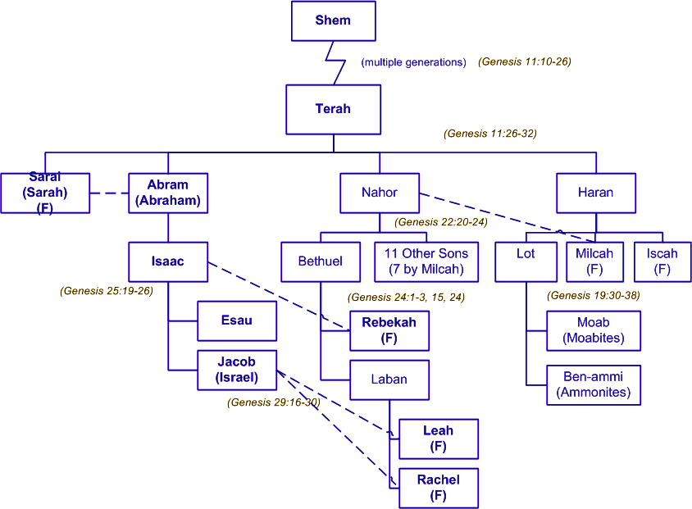

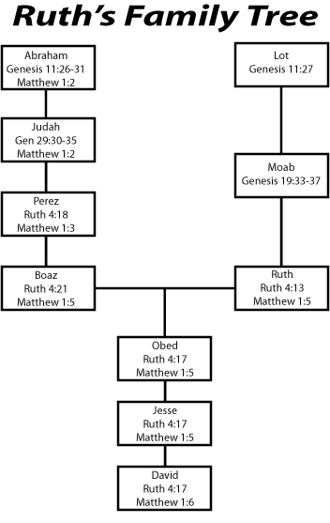

Genesis 23: 1-20
Sarah lived to be a hundred and twenty-seven years old. 2 She died at Kiriath Arba (that is, Hebron) in the land of Canaan, and Abraham went to mourn for Sarah and to weep over her.

About 35 years have passed since the last mention of Abraham's wife Sarah. At that prior incident, a celebration for the weaning of their son, Isaac, Sarah insisted that Ishmael, Isaac's half-brother, should be sent away, along with his mother, Hagar (Genesis 21:10). Sarah is not mentioned in the previous chapter's description of Abraham's near-offering of Isaac in obedience to God's command.

Despite her own doubts, Sarah was finally given the child promised by God, when she was 90 years old (Genesis 17:17). Now Sarah has died at the age of 127, making Abraham around 137 years old and their son Isaac around 37.

Abraham's wife Sarah dies in a place called Kiriath-arba, later known to the Israelites as Hebron. When we left chapter 22, they had been living in Beersheba. Hebron is located between Beersheba and Jerusalem, about 20 miles south of Jerusalem, close to Mamre.

In addition to expressing his great sorrow, Abraham may also have followed the traditions for mourning the dead that would have included the tearing of garments, rubbing of ashes, and fasting.

The following verses are the first great examples of bad placement of verse numbers which happened in Paris in 1557:

3 Then Abraham rose from beside his dead wife and spoke to the Hittites. He said,

4 “I am a foreigner and stranger among you. Sell me some property for a burial site here so I can bury my dead.”

5 The Hittites replied to Abraham, 6 “Sir, listen to us. You are a mighty prince among us. Bury your dead in the choicest of our tombs. None of us will refuse you his tomb for burying your dead.”

When the time of mourning for Sarah had ended, Abraham rose up and went out from the presence of her body. His next mission was to find a place to bury her. It is important to Abraham to find a permanent burying place for his people in the land of Canaan. He will have to buy one and take clear ownership of it.

The area around their current dwelling place in Hebron was owned by a group known as the Hittites. Hittites means "sons of Heth." Heth was one of the sons of Canaan, a grandson of Noah. These Hittites, then, are clearly Canaanites of the land of Canaan, as opposed to other "Hittites" known from history.

This will become important, because Abraham will attempt to take full ownership of this burying place from the rightful owners of the land in the most public and indisputable manner possible.

Their warm, kind response here echoes the nature of his request to them. Abraham had called himself a sojourner and foreigner. They call him a prince of God or mighty price of God among them. In other words, they do not view Abraham as a mere wanderer; they see him as powerful, blessed by God, and worthy to be among them.

In fact, very generously, they insist that none of them would withhold from Abraham his own tomb for the purpose of burying his people, presumably starting with Sarah. However, their response does not acknowledge Abraham's request for a property of his own. He is not asking to share a tomb; he is asking to acquire a permanent possession, as the following verses will make clear.

7 Then Abraham rose and bowed down before the people of the land, the Hittites. 8 He said to them, “If you are willing to let me bury my dead, then listen to me and intercede with Ephron son of Zohar on my behalf 9 so he will sell me the cave of Machpelah, which belongs to him and is at the end of his field. Ask him to sell it to me for the full price as a burial site among you.”

Abraham stood to formally address the assembled group of Hittites. The assumption is that this group of landowners or elders is recognized as some kind of official governing body. Abraham wishes for the negotiation that will follow to be recognized as binding and lasting.

Now Abraham reveals that he has a very specific property in mind. The group as a whole has granted their willingness for him to bury his dead in the area, though not yet in a property that he will own as a permanent possession. In front of the group, he stands and singles out Ephron, the son of Zohar. Abraham then makes his opening offer to buy it at full price.

10 Ephron the Hittite was sitting among his people and he replied to Abraham in the hearing of all the Hittites who had come to the gate of his city. 11 “No, my lord,” he said. “Listen to me; I give you the field, and I give you the cave that is in it. I give it to you in the presence of my people. Bury your dead.”

It’s unlikely that Ephron intended to actually "gift" the field and cave to Abraham without payment. Most likely, this was simply the customary pattern of Middle Eastern bargaining at this time in history. This partly explains why Ephron includes the field as well as the cave; he is countering Abraham's request by increasing the size of the transaction. Perhaps Ephron did not want to sell the cave without the field, so he offered to "give" them both to Abraham, knowing Abraham would then offer to pay for them.

12 Again Abraham bowed down before the people of the land 13 and he said to Ephron in their hearing, “Listen to me, if you will. I will pay the price of the field. Accept it from me so I can bury my dead there.”

For the second time in this negotiation with the Hittites, Abraham bows before the people. In both cases, he does so just before he is to resist an offer and insist on his own position. Again, this respectful approach may have been customary of Middle Eastern bargaining of the time. An interesting aspect of this negotiation is that Abraham is bargaining to buy land that God has promised to give Abraham's descendants. Greater fulfillment of that oath won't occur until Israel begins to settle in Canaan after the Exodus from Egypt.

14 Ephron answered Abraham, 15 “Listen to me, my lord; the land is worth four hundred shekels of silver, but what is that between you and me? Bury your dead.”

Ephron responds using a phrase uttered by several parties in this back-and-forth conversation: "Listen to me" or "hear me." It could be taken to mean, "Seriously, I mean this." Ephron names a price for the field in the most casual and non-committal way he can. His offer suggests that, since he had previously offered to give the field Abraham, how insignificant is 400 shekels of silver between two friends? In other words, he is agreeing to Abraham's terms of full ownership, but for the price of 400 shekels of silver.

Again, Ephron ends his offer with "bury your dead," implying that he is being generous in helping Abraham to get past this unpleasant negotiating and back to the business of burying his wife Sarah. This is also a shrewd business tactic: reminding the buyer of what they stand to gain when they "seal the deal."

16 Abraham agreed to Ephron’s terms and weighed out for him the price he had named in the hearing of the Hittites: four hundred shekels of silver, according to the weight current among the merchants.

Abraham's negotiation with Ephron the Hittite for the purchase of his cave and field at Machpelah has concluded. Negotiation may not be quite the right word, however. Abraham immediately accepts the first price Ephron mentions, agreeing to purchase the field along with the cave he initially asked about.

For Abraham, the most important thing was to have the full legal ownership rights to this property, something he ensured by purchasing the cave and field in full view of the "people of the land" (Genesis 23:12). There could be no legitimate dispute as to who owned this property.

Why was this so important? In this era, people were often buried in their homeland, entombed along with their ancestors. Abraham's decision to bury Sarah, and later to be buried himself, in Canaan, was a declaration of faith that this would become the permanent homeland of his offspring. This is somewhat unusual in that the land Abraham just purchased is part of what God has promised to his descendants.

17 So Ephron’s field in Machpelah near Mamre—both the field and the cave in it, and all the trees within the borders of the field—was deeded 18 to Abraham as his property in the presence of all the Hittites who had come to the gate of the city.

This verse lists the details of the transaction. The property in Machpelah, east of Mamre, is "made over" to Abraham. The purchase includes the cave, the field, and all the trees within the boundaries of the field. The following verse completes the details of the transaction.

This act of burial has particular significance in that time period. Choosing to bury one's dead in a specific place was a sign of both residency and ownership. Even though he has to buy it, Abraham is able to take possession, within his lifetime, of a small portion of the Promised Land.

All of this small parcel is now "made over" to Abraham as his possession. The transaction is concluded in full view of the Hittites and all who go in at the gate of the city. These are likely the elders of Hebron. This is a public and legal transaction according the customs of the land at this time.

19 Afterward Abraham buried his wife Sarah in the cave in the field of Machpelah near Mamre (which is at Hebron) in the land of Canaan. 20 So the field and the cave in it were deeded to Abraham by the Hittites as a burial site.

Until Sarah died and was buried in the land of promise, it was always potentially possible for Abraham to give up on God's promises and "go home." He never did, and his decisive action to buy a burial place for Sarah and himself and their descendants in Canaan showed that he had fully cut his ties to his old life. Canaan, the land of promise, was home for now and for his people forever.

R.C. Sproul: As Christians, we know that death was not originally a part of the created order but crept in when Adam ate the forbidden fruit (Gen. 2:16–17). Nevertheless, we are sad when loved ones pass, because death means we lose, for a time, the intimacy we had with them. However, unlike those who do not trust Christ, for Christians death is not finally a tragedy. Instead, we find the greatest opportunity of all to display our faith when we are face-to-face with the grave. This is precisely what we learn from Abraham in Genesis 23.

The patriarch could have doubted God when Sarah passed, for she died without seeing the divine promises fulfilled. Yet Abraham persevered, buying a burial plot as a sign of his confidence in the Lord’s blessing (v. 16). He and his wife would inherit Canaan after their deaths if need be. In the meantime, their bodies would lie in the ground not far from the place where Sarah first heard she would be a part of the promise by giving birth to Isaac (18:1–15). As one commentator has said, their bones bore witness to future generations of their hope that the Lord would do so much more for them at the resurrection than he did during their lives.

We too may die before Jesus returns to place the whole earth into the hands of His people (Matt. 5:5). Yet our confidence in the Father enables us to know that all His promises will surely come to pass, even if they must come after our lifetime. May we, like Abraham and Sarah, trust God to be faithful in life and in death (Heb. 11:13–16).

