The Patriarchs from the book of Genesis Part 14 – October 29, 2023
With input from https://www.bibleref.com/Genesis/20/Genesis-20-18.html;
The Genesis Record by Henry Morris; https://bible-history.com/biblemaps/sodom-and-gomorrah-3

Genesis 20:1-18:
Now Abraham journeyed from there (according to chapter 18: “the Lord appeared to Abraham by the oaks of Mamre”)- So up to this point Abraham has been in that location.

toward the land of the Negev (the Negev – a definite article is used because it is used as an identifier for a certain region), and settled between Kadesh and Shur; then he lived for a time in Gerar.

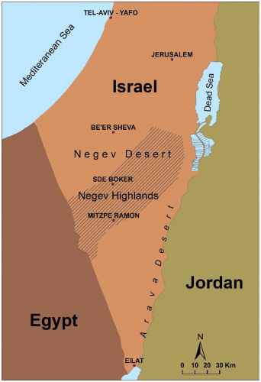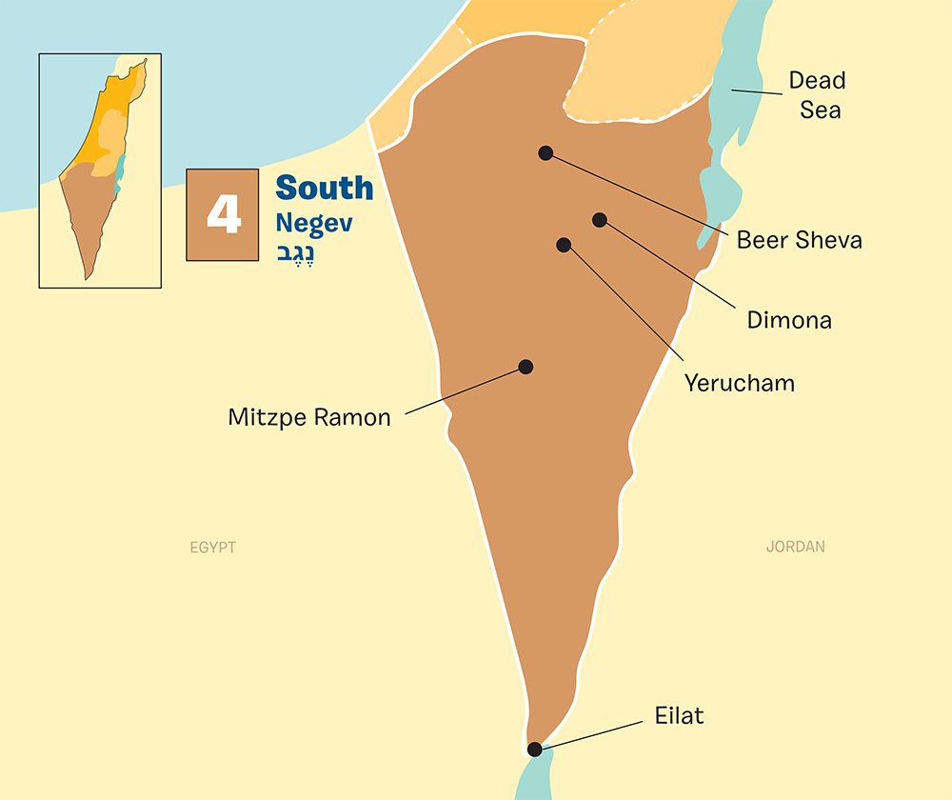

Although that region is now pretty much an arid desert, in Biblical times it was forested (Ezekiel 20:46-47) and appears to have contained a considerable human population (Jeremiah 17:26, Zechariah 7:7), spread out over several cities (Jeremiah 13:19, 32:44, 33:13, Obadiah 1:19-20), namely Kadesh, Bered, Arad and Shur and perhaps also Zephath and Gerar, of which Abimelech was king (Genesis 20:2).

This is also the area that Abraham went to after leaving Egypt when he first declared Sarai as his sister and not his wife, to the Pharaoh.

2 And Abraham said of his wife Sarah, “She is my sister.” Abraham did not learn this lesson the first time and makes the same mistake again as he did in Genesis 12. But we will see in verse 13 that this was a lie they decided to use decades earlier when they left Abraham’s father’s house.

Henry Morris: “It might be understandable the first time in Egypt when their faith had not yet really been tested and God’s faithfulness fully confirmed. But how could they do it again? They had stood through many tests and God had not failed them.

So Abimelech king of Gerar sent men and took Sarah. Note that Sarah is now 90, and possibly pregnant. Was she still so beautiful that Abimelech required that she be in his harem?

3 But God came to Abimelech in a dream of the night, and said to him, “Behold, you are a dead man because of the woman whom you have taken, for she is married.”
Because of verse 17, we understand here that Abimelech was sick “was like a dead man”.

4 Now Abimelech had not come near her; and he said, “Lord, will You kill a nation, even though blameless? 5 Did he himself not say to me, ‘She is my sister’? And she herself said, ‘He is my brother.’ In the integrity of my heart and the innocence of my hands I have done this.”

6 Then God said to him in the dream, “Yes, I know that in the integrity of your heart you have done this, and I also kept you from sinning against Me; therefore I did not let you touch her.
Does God use something we would put in category “bad” to keep us from making a mistake, or to keep us from harm?”

7 Now then, return the man’s wife, for he is a prophet, and he will pray for you and you will live. But if you do not return her, know that you will certainly die, you and all who are yours.”

God describes Abraham as a prophet and that Abraham needed to pray so that Abimelech will be healed. This is the first appearance of the word “prophet” in the bible and shows that “prophecy” is not primarily prediction, but rather speaking the words of God, as inspired by Him.

8 So Abimelech got up early in the morning and called all his servants, and told all these things in their presence; and the people were greatly frightened. 9 Then Abimelech called Abraham and said to him, “What have you done to us? And how have I sinned against you, that you have brought on me and on my kingdom a great sin? You have done to me things that ought not to be done.”

Abimelech wants to know what he has ever done to Abraham. It's a question asked by a reasonable person: Did I do something to deserve this terrible treatment from you? Unlike the Pharaoh, Abimelech also identifies this near-adultery as a great sin with consequences for himself and his whole kingdom. He seems to agree with God that adultery is wrong. He says clearly to Abraham: You shouldn't have done this.

10 And Abimelech said to Abraham, “What have you encountered, that you have done this thing?”
After beginning with an angry series of confrontational questions in the previous verse, Abimelech's question here seems more pointed. He genuinely wants to know why Abraham lied and said that Sarah was his sister. More specifically, Abimelech asks what Abraham has seen or encountered that would motivate this kind of deception. Abimelech honestly doesn't get it. In light of all of God's goodness to Abraham, his answer in the following verses will not be very satisfying to us either, though it will sound very human.

11 Abraham said, “Because I thought, surely there is no fear of God in this place, and they will kill me because of my wife.
Abraham's answer reveals how his fear in that situation overcame his faith in God, and an apparent misunderstanding about the faith of Abimelech and his people. Abraham believed there was no fear of God in Gerar. He believed someone might kill him to take Sarah for his own. Notice that Abraham, again, was not wrong about Sarah's desirability. She must have been extremely attractive. Both in Egypt years earlier and now in Gerar, the most powerful man in the area quickly took her for his own wife (Genesis 12:14–15).

Abraham was wrong, though, about God's ability and/or willingness to protect him and Sarah. His lack of faith is hard for us, as readers of the Bible, to fully understand. Abraham has literally walked and talked with the Lord. He has seen God utterly destroy the wicked people of Sodom and Gomorrah while rescuing his own nephew Lot from among them. He has received blessing after blessing from the Lord, alongside powerful promises, including one that Sarah will bear him a son within the year.

Abraham was also wrong, it seems, about the lack of faith in God in Gerar. If they didn't have it before, the king and his people certainly learned to fear the Lord very quickly under threat of death from God.

12 Besides, she actually is my sister, the daughter of my father, but not the daughter of my mother; and she became my wife;
Now he reveals that it's not completely a lie. She is his half-sister, as well as being his wife. They share the same father and different mothers. Of course, even true statements, told with the intent to deceive and to disguise some other important truth, are still lies. Abraham was acting in fear for his own life, and he knew full well what he was doing.

Though God, in the Law of Moses, would later forbid marriage for those in that closeness of family, it was apparently not uncommon or disapproved of in Abraham's day. God never seems to have condemned Abraham or Sarah for it, either. In contrast, the relations between Lot and his daughters described in the previous chapter was apparently thought to be wrong both in Abraham's time and, later, under the Law of Moses.

13 and it came about, when God caused me to wander from my father’s house, that I said to her, ‘This is the kindness which you will show to me: everywhere we go, say of me, “He is my brother.”’”
As details appear, it becomes harder for us to sympathize with Abraham in this situation. He is admitting, here, that he has repeatedly asked Sarah to put herself in harm's way in order to save his own life. In addition, this is only the second time Scripture has mentioned him doing this when coming to a new place (Genesis 12:12–13). So, is Abraham lying about it being their normal routine? Or has it happened in other places, as well? We don't know.

14 Abimelech then took sheep and oxen and male and female servants, and gave them to Abraham, and returned his wife Sarah to him.
Now, Abimelech does return Sarah, but he goes well beyond that. He also gives Abraham sheep, oxen, and servants, in addition to a large sum of silver mentioned in verse 16. Abimelech seems eager to clear away any hint of this potential sin and any scandal between him, Abraham, and Sarah.

This is not only a sign of good will from Abimelech, it is an important part of God protecting the promise he made to provide Abraham and Sarah with a natural-born son (Genesis 17:15–16). The fact that Abimelech, in no uncertain terms, never touched Sarah maintains the upcoming birth of Abraham's son, Isaac, as legitimate.

15 Abimelech said, “Behold, my land is before you; settle wherever you please.” 16 To Sarah he said, “Look, I have given your brother a thousand pieces of silver. It is your vindication before all who are with you, and before everyone you are cleared.”
Notice that while telling this to Sarah, he still calls Abraham her "brother" and not her husband. Since that was the half-truth, half-lie used by Abraham, Abimelech might mean that statement as a not-so-subtle sign of his continued displeasure with fearful Abraham.

In addition to returning Sarah, along with gifts of herds, flocks, and servants, the king of Gerar offers to allow Abraham to settle anywhere in his kingdom that he would like.

It's hard to imagine he was happy with Abraham. More likely, the king was eager for Abraham to pray for him and for his household so that they would live. It's also possible that Abimelech wanted to prove his good intentions to the Lord.

17 Then Abraham prayed to God, and God healed Abimelech and his wife and his female slaves, so that they gave birth to children.

God healed after Abraham prayed. Why did God require the middle step of another person's prayer before taking action? God often works that way, especially through his prophets in the Old Testament and in the church today. God stands ready to exercise His power in response to the prayers of His people. He wants us to ask; He acts when we do: James 5:17–18: Elijah was a man with a nature like ours, and he prayed earnestly that it would not rain, and it did not rain on the earth for three years and six months. 18 Then he prayed again, and the sky poured rain and the earth produced its fruit.

18 For the Lord had completely closed all the wombs of the household of Abimelech because of Sarah, Abraham’s wife.
This established two points that are important when interpreting this incident. First, Sarah must have been in Abimelech's household for a while before God appeared to him in the dream. She had to be there long enough for it to become apparent that the women of the household could not bear children. That's not something one can realize in a few short days, or even weeks.

Second, this shows us once again that God exercises complete control over fertility, giving and withholding children as He sees fit. Psalm 127:3 indicates that children are a gift from the Lord. He sometimes withholds them in judgment, as He did here, or until the time is right, as will happen with the birth of Isaac in the following chapter. At still other times, He withholds children without explanation or condemnation. In all cases, His people are called to trust the Father's timing, His grace, and His love.

